**ICT - (PROJECT)**

Car Dealership Portfolio

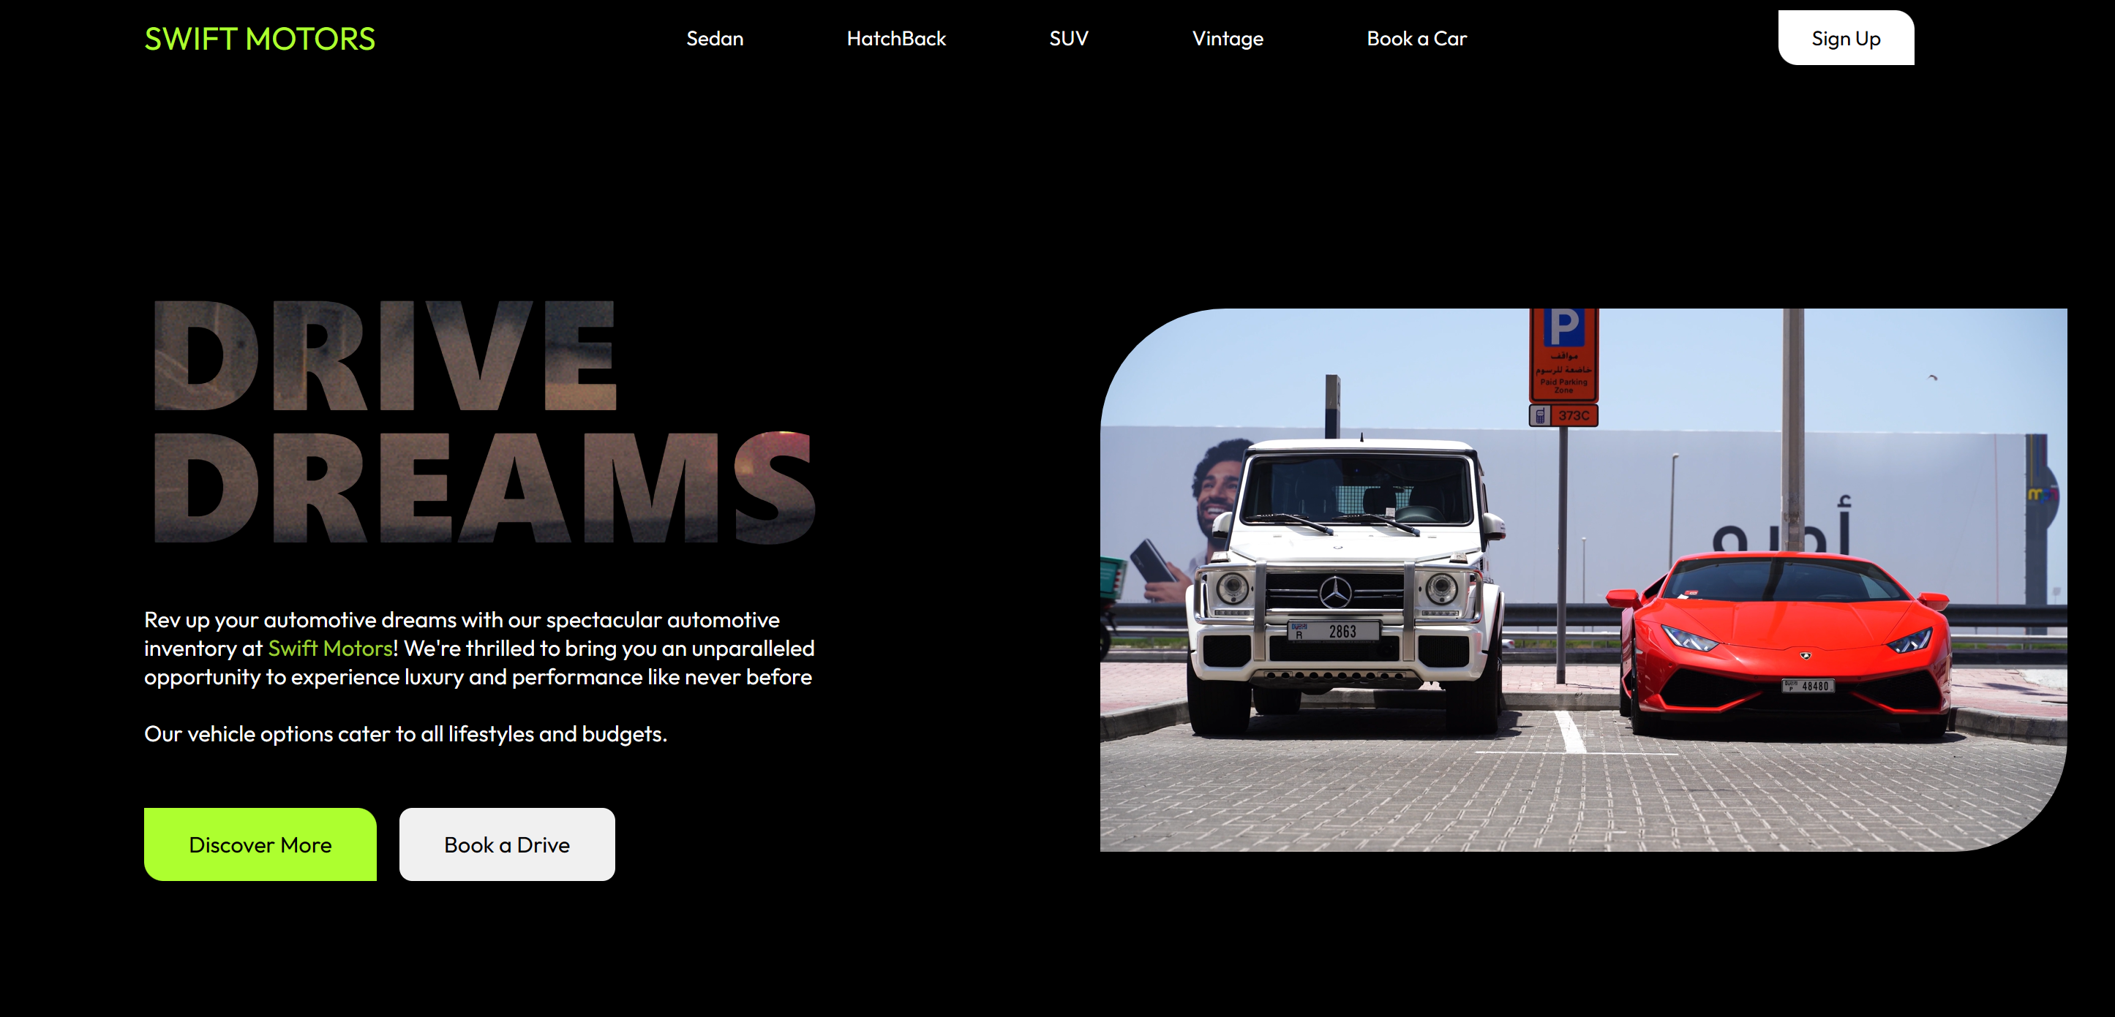

**Submitted By:**

Ali Hassan

232406

BSCSev-C

**Submitted To:**

Ma’am Kainat

Group Members:

01: Ali Hassan

02: Null

PHASE-1

**Purpose:**

The purpose of developing this website is to provide the business a way to represent their brand online and what sort of vehicles they deal in. This is not a marketplace rather will provide information on vehicles, allowing users to book inspections and test drives. The users would be able to explore different sections classified on the basis of types of vehicles from Sedans, SUVs, Hatchbacks, and Vintage collection.

**Target Audience:**

The target audience includes potential buyers who are looking up for businesses dealing in exclusive vehicles, which would cater their desired vehicle and offer multiple options.

**Prototype UI:**

Access it through link below for latestly updates figma design

[alisproject – figma](https://www.figma.com/file/ENCOexUH1zX2ezynxiODaP/aliproject?type=design&node-id=15%3A150&mode=design&t=79pRBz9wOaAazGPL-1)

OR

A png has been attached on the last page.

PHASE-2

**Project Requirements:**

1. Navigation Bar which would link to different classified sections on the website. ie(Sedans, Hatchbacks, SUVs, vintages or Booking a test drive.
2. Buttons: Call to Actions button for such as booking a test drive or discovering more. Sign in button in the nav bar.
3. Home Page displaying an introduction and a video to catch attention.
4. The website will be divided into sections ie. Sedans, SUVs, Hatchbacks, Vintage and Book a Test Drive.
5. Each of the section will have a car listing category to be further discovered by the user.
6. Next Buttons to further move to the next pages.
7. Responsive Design will allow the user to access the website neatly throught out all devices without any disorders.
8. CSS to provide a clean, minimal and sleek design to the website. Hover effects on buttons, animations on divs, gradient backgrounds in footer.
9. A sleek and appealing font to further uplift the website and provide visual enhancements.
10. Form for booking a test drive for a vehicle.
11. Webkit css properties to put in effects on text as background and further scroll behaviors.

**User Stories:**

Here are user stories for some of the functionalities I would add to in my car dealership website:

1. Navigation Bar: As a user, I want a clear and well-organized navigation bar at the top, so I can quickly access different sections like Home, and different pages like, Sedans, SUV, Hatchbacks, Vintage, and Book a test Drive as well as a location page.
2. Stylish Buttons: As a user, I want appealing buttons so I can easily identify and click on actions like "Book a Test Drive” etc.
3. Responsive Design: As a user, I want the website to look and function well on various devices, so I can access it from my desktop, tablet, or mobile phone.
4. Hover Effects: As a user, I want images or buttons to change appearance when I hover over them, so I can have a more interactive experience.
5. Typography: As a user, I want the text on the website to be readable so I can easily consume information.
6. Section Backgrounds: As a user, I want visually appealing section backgrounds, so the website feels engaging.
7. Forms: As a user, I want a clean and user-friendly form for booking a test drive, so I can easily provide the required information.
8. CSS Transforms: As a user, I want to see subtle animations or effects, such as scaling images on hover, to make the website more visually interesting.
9. Footer Design: As a user, I want a well-designed footer with links to social media, and additional contact details, so I can access additional information if needed.

**Design Elements**:

Vanilla CSS and Figma for UI Design

**Color Scheme:**

**White - #F5FCEE -**

**Black - #060802 -**

**Green - #adff2f -**

**Blue - #2b3674 -**

**Font Scheme:**

Font from google “Outfit” and its alternate “sans-serif”

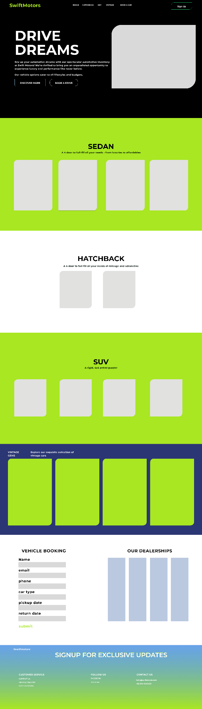

The next Parts of front end development and git setup are done in the form of code and repository can be accessed through this link – [project-repo-link](http://www.Github.com/whizali/ProjectWebDev)